SECTION 1: Identification

1.1. Product identifier
Product name | : | eXact color - Mixture
Product code | : | 12010

1.2. Recommended use and restrictions on use
Recommended use | : | Caulking
This SDS is designed for workplace employees, emergency personnel and for other situations where there is potential for large-scale or prolonged exposure, in accordance with the WHMIS GHS requirements.
This SDS is not applicable for consumer use of our products. For consumer use, all precautionary and first aid language is provided on the product label, SDS or both in accordance with applicable government regulations.

1.3. Supplier
Supplier  Sashco Inc.  14802 Grant St.  Thornton, CO, 80023  USA  T 800-767-5656  info@sashco.com | Distributor  Add the name, address and tel. number of the Canadian manufacturer or importer who operates in Canada.

1.4. Emergency telephone number
Emergency number | : | 800-535-5053

SECTION 2: Hazard identification

2.1. Classification of the substance or mixture

Classification (GHS CA)
STOT RE 2 | H373 | May cause damage to organs (kidneys) through prolonged or repeated exposure (oral).

2.2. GHS Label elements, including precautionary statements

GHS-CA labelling
Hazard pictograms (GHS-CA) | : | 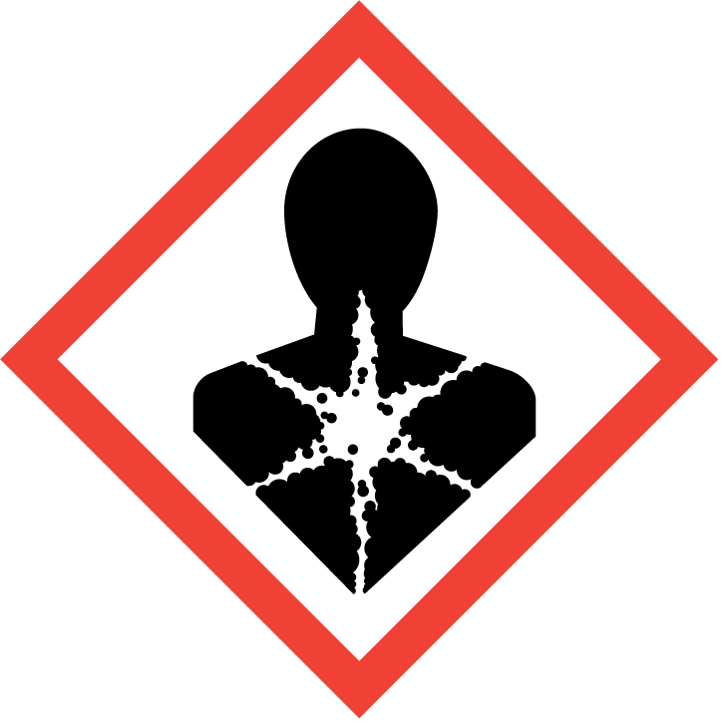
Signal word (GHS CA) | : | Warning

Hazard statements (GHS-CA) | : | H373 - May cause damage to organs (kidneys) through prolonged or repeated exposure (oral).
Precautionary statements (GHS-CA) | : | P101 - If medical advice is needed, have product container or label at hand.  P102 - Keep out of reach of children.  P103 - Read label before use.  P260 - Do not breathe fume, spray, vapours.  P314 - Get medical advice/attention if you feel unwell.  P501 - Dispose of contents/container to hazardous or special waste collection point, in accordance with local, regional, national and/or international regulation.

2.3. Other hazards
No additional information available

2.4. Unknown acute toxicity (GHS CA)
Not applicable

SECTION 3: Composition/information on ingredients

3.1. Substances
Not applicable

3.2. Mixtures
Name | Chemical name / Synonyms | Product identifier | %
Distillates, petroleum, hydrotreated heavy paraffinic | Heavy paraffinic hydrotreated distillate / Distillates, petroleum, hydrotreated heavy paraffinic (A complex combination of hydrocarbons obtained by treating a petroleum fraction with hydrogen in the presence of a catalyst. It consists of hydrocarbons having carbon numbers predominantly in the range of C20-50 and produces a finished oil of at least 100 SUS at 100°F (19cSt at 40°C). It contains a relatively large proportion of saturated hydrocarbons.) / Paraffin oil / HYDROGENATED MINERAL OIL / Hydrogenated mineral oil / Distillates (petroleum), hydrotreated heavy paraffinic / Petroleum distillates, hydrotreated heavy paraffinic | CAS-No.: 64742-54-7 | 5 – 10
2-Amino-2-methyl-1-propanol | 2-Amino-2-methylpropan-1-ol / Isobutanol-2-amine / Isobutanolamine / Propan-1-ol, 2-amino-2-methyl- / 1-Propanol, 2-amino-2-methyl- / 2-Amino-2-methylpropanol / AMINOMETHYL PROPANOL / Aminomethyl propanol / AMP / Aminomethylpropanol | CAS-No.: 124-68-5 | 1 – 5
Ethylene glycol | 1,2-Dihydroxyethane / Ethane-1,2-diol / 1,2-Ethanediol / Ethanediol / GLYCOL / Glycol / Monoethylene glycol | CAS-No.: 107-21-1 | 1 – 5
Sodium dodecylbenzenesulfonate | Dodecylbenzenesulphonic acid, sodium salt / Sodium laurylbenzenesulfonate / Sodium laurylbenzenesulphonate / sodium dodecylbenzenesulfonate / Sodium lauryl benzene sulphonate / SODIUM DODECYLBENZENESULFONATE / Benzenesulfonic acid, dodecyl-, sodium salt (1:1) / Sodium dodecylbenzenesulphonate / Dodecylbenzenesulfonic acid, sodium salt / Benzenesulfonic acid, dodecyl-, sodium salt / Benzenesulfonate, dodecyl-, sodium | CAS-No.: 25155-30-0 | 0.1 – 1

Comments | : | *Chemical name, CAS number and/or exact concentration have been withheld as a trade secret

SECTION 4: First-aid measures

4.1. Description of first aid measures
First-aid measures after inhalation | : | If breathing is difficult, remove victim to fresh air and keep at rest in a position comfortable for breathing. Get medical advice/attention if you feel unwell.
First-aid measures after skin contact | : | If skin irritation occurs: Wash skin with plenty of water. Obtain medical attention if irritation persists.
First-aid measures after eye contact | : | IF IN EYES: Rinse cautiously with water for several minutes. Remove contact lenses, if present and easy to do. Continue rinsing. If eye irritation persists: Get medical advice/attention.
First-aid measures after ingestion | : | Do not induce vomiting without medical advice. Never give anything by mouth to an unconscious person. Get medical advice/attention if you feel unwell.
First-aid measures general | : | Get medical advice/attention if you feel unwell.

4.2. Most important symptoms and effects (acute and delayed)
Symptoms/effects after inhalation | : | May cause irritation to the respiratory tract.
Symptoms/effects after skin contact | : | May cause skin irritation. Repeated exposure may cause skin dryness or cracking.
Symptoms/effects after eye contact | : | May cause eye irritation. Symptoms may include discomfort or pain, excess blinking and tear production, with possible redness and swelling.
Symptoms/effects after ingestion | : | May be harmful if swallowed. May cause gastrointestinal irritation, nausea, vomiting and diarrhea.
Chronic symptoms | : | May cause damage to organs through prolonged or repeated exposure.

4.3. Immediate medical attention and special treatment, if necessary
Other medical advice or treatment | : | Symptoms may be delayed. In case of accident or if you feel unwell, seek medical advice immediately (show the label where possible).

SECTION 5: Fire-fighting measures

5.1. Suitable extinguishing media
Suitable extinguishing media | : | Use extinguishing media appropriate for surrounding fire.

5.2. Unsuitable extinguishing media
Unsuitable extinguishing media | : | Direct water spray may cause frothing.

5.3. Specific hazards arising from the hazardous product
Fire hazard | : | Products of combustion may include, and are not limited to: oxides of carbon. Acrylic monomers.

5.4. Special protective equipment and precautions for fire-fighters
Protection during firefighting | : | Keep upwind of fire. Wear full fire fighting turn-out gear (full Bunker gear) and respiratory protection (SCBA).

SECTION 6: Accidental release measures

6.1. Personal precautions, protective equipment and emergency procedures
General measures | : | Use personal protection recommended in Section 8. Isolate the hazard area and deny entry to unnecessary and unprotected personnel.

6.2. Methods and materials for containment and cleaning up
For containment | : | Absorb and/or contain spill with inert material (sand, vermiculite or other appropriate material), then place in suitable container. Prevent further leakage or spillage. Keep away from drains, surface and ground-water and soil. Do not flush into surface water or sewer system. Wear recommended personal protective equipment.
Methods for cleaning up | : | Sweep or shovel spills into appropriate container for disposal. Provide ventilation.

6.3. Reference to other sections
For further information refer to section 8: "Exposure controls/personal protection"

SECTION 7: Handling and storage

7.1. Precautions for safe handling
Precautions for safe handling | : | Avoid contact with skin and eyes. Do not breathe fume, spray, vapours. Do not swallow. Handle and open container with care. When using do not eat, drink or smoke.
Hygiene measures | : | Wash contaminated clothing before reuse. Wash hands, forearms and face thoroughly after handling.

7.2. Conditions for safe storage, including any incompatibilities
Storage conditions | : | Keep out of the reach of children. Keep container tightly closed. Store at room temperature. Keep from freezing. Store locked up.

SECTION 8: Exposure controls/personal protection

8.1. Control parameters

Ethylene glycol (107-21-1)
USA - ACGIH - Occupational Exposure Limits
ACGIH OEL TWA [ppm] | 25 ppm (vapor fraction)
ACGIH OEL STEL | 10 mg/m³ (inhalable particulate matter, aerosol only)
ACGIH OEL STEL [ppm] | 50 ppm (vapor fraction)
ACGIH chemical category | Not Classifiable as a Human Carcinogen

8.2. Appropriate engineering controls
Appropriate engineering controls | : | Ensure good ventilation of the work station. Provide readily accessible eye wash stations and safety showers.
Environmental exposure controls | : | Avoid release to the environment.

8.3. Individual protection measures/Personal protective equipment
Hand protection:
Wear suitable gloves. Consult glove manufacturer's product information on material suitability and material thickness.

Eye protection:
Safety glasses or goggles are recommended when using product.

Skin and body protection:
Wear suitable protective clothing

Respiratory protection:
In case of insufficient ventilation, wear suitable respiratory equipment. Respirator selection must be based on known or anticipated exposure levels, the hazards of the product and the safe working limits of the selected respirator. SDSs cannot provide detailed and complete respiratory protection guidelines. Selection of respiratory protection must be done by a qualified person who has assessed the work environment.

Other information:
Handle in accordance with good industrial hygiene and safety procedures. Do not eat, drink or smoke when using this product.

SECTION 9: Physical and chemical properties

9.1. Information on basic physical and chemical properties
Physical state | : | Liquid
Appearance | : | Paste.
Colour | : | White
Odour | : | Sweet
Odour threshold | : | No data available
pH | : | 9
Relative evaporation rate (butylacetate=1) | : | > 1
Relative evaporation rate (ether=1) | : | No data available
Melting point | : | No data available
Freezing point | : | No data available
Boiling point | : | 212 °F (100 °C)
Flash point | : | Not applicable
Auto-ignition temperature | : | No data available
Decomposition temperature | : | No data available
Flammability (solid, gas) | : | No data available
Vapour pressure | : | No data available
Relative vapour density at 20°C | : | No data available
Relative density | : | 1.04
Solubility | : | Negligible.
Partition coefficient n-octanol/water | : | No data available
Viscosity, kinematic | : | 200000 mm²/s
Explosive limits | : | No data available

9.2. Other information
No additional information available

SECTION 10: Stability and reactivity
Reactivity | : | No dangerous reactions known under normal conditions of use.
Chemical stability | : | Stable under normal conditions.
Possibility of hazardous reactions | : | No dangerous reactions known under normal conditions of use.
Conditions to avoid | : | Heat.
Incompatible materials | : | None known.
Hazardous decomposition products | : | May include, and are not limited to: oxides of carbon.
Hardening time: | : | No additional information available

SECTION 11: Toxicological information

11.1. Information on toxicological effects
Acute toxicity (oral) | : | Not classified.
Acute toxicity (dermal) | : | Not classified.
Acute toxicity (inhalation) | : | Not classified.

Sodium dodecylbenzenesulfonate (25155-30-0)
LD50 oral rat | 500 mg/kg
LC50 inhalation rat | 310 mg/m³ (Exposure time: 4 h)
ATE CA (oral) | 500 mg/kg bodyweight
ATE CA (vapours) | 0.31 mg/l/4h
ATE CA (dust,mist) | 0.31 mg/l/4h

Distillates, petroleum, hydrotreated heavy paraffinic (64742-54-7)
LD50 oral rat | > 15 g/kg
LD50 dermal rabbit | > 5000 mg/kg

Ethylene glycol (107-21-1)
LD50 oral rat | 4700 mg/kg
LD50 dermal rat | 10600 mg/kg
LC50 inhalation rat | > 2.5 mg/l (Exposure time: 6 h)
ATE CA (oral) | 500 mg/kg bodyweight

2-Amino-2-methyl-1-propanol (124-68-5)
LD50 oral rat | 2900 mg/kg
LD50 dermal rabbit | > 2000 mg/kg
ATE CA (oral) | 2900 mg/kg bodyweight

Skin corrosion/irritation | : | Not classified.  pH: 9

Serious eye damage/irritation | : | Not classified.  pH: 9

Respiratory or skin sensitization | : | Not classified.

Germ cell mutagenicity | : | Not classified.

Carcinogenicity | : | Not classified.

Reproductive toxicity | : | Not classified.

STOT-single exposure | : | Not classified.

STOT-repeated exposure | : | May cause damage to organs (kidneys) through prolonged or repeated exposure (oral).

Aspiration hazard | : | Not classified.

Symptoms/effects after inhalation | : | May cause irritation to the respiratory tract.
Symptoms/effects after skin contact | : | May cause skin irritation. Repeated exposure may cause skin dryness or cracking.
Symptoms/effects after eye contact | : | May cause eye irritation. Symptoms may include discomfort or pain, excess blinking and tear production, with possible redness and swelling.
Symptoms/effects after ingestion | : | May be harmful if swallowed. May cause gastrointestinal irritation, nausea, vomiting and diarrhea.
Chronic symptoms | : | May cause damage to organs through prolonged or repeated exposure.
Other information | : | Likely routes of exposure: ingestion, inhalation, skin and eye.

SECTION 12: Ecological information

12.1. Toxicity
Ecology - general | : | May cause long-term adverse effects in the aquatic environment.

12.2. Persistence and degradability
No additional information available

12.3. Bioaccumulative potential
No additional information available

12.4. Mobility in soil
No additional information available

12.5. Other adverse effects
No additional information available

SECTION 13: Disposal considerations

13.1. Disposal methods
Product/Packaging disposal recommendations | : | Dispose of contents/container to hazardous or special waste collection point, in accordance with local, regional, national and/or international regulation.

SECTION 14: Transport information
In accordance with TDG

14.1. UN number
Not regulated for transport

14.2. UN proper shipping name
Proper Shipping Name (TDG) | : | Not applicable

14.3. Transport hazard class(es)
TDG
Transport hazard class(es) (TDG) | : | Not applicable

14.4. Packing group
Packing group (TDG) | : | Not applicable

14.5. Environmental hazards
Other information | : | No supplementary information available.

14.6. Special precautions for user
Special transport precautions | : | Do not handle until all safety precautions have been read and understood.

TDG
No data available

14.7. Transport in bulk according to Annex II of MARPOL 73/78 and the IBC Code
Not applicable

SECTION 15: Regulatory information

15.1. National regulations
No additional information available

15.2. International regulations
No additional information available

SECTION 16: Other information
Issue date | : | 05-24-2023
Revision date | : | 05-24-2023

Other information | : | None.
Prepared by | : |   Nexreg Compliance Inc.  www.Nexreg.com

NFPA health hazard | : | 0 - Materials that, under emergency conditions, would offer no hazard beyond that of ordinary combustible materials. | 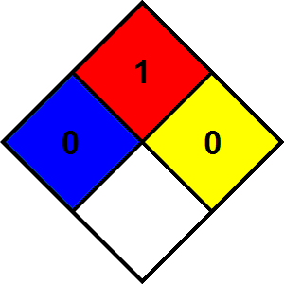
NFPA fire hazard | : | 1 - Materials that must be preheated before ignition can occur.
NFPA reactivity | : | 0 - Material that in themselves are normally stable, even under fire conditions.

Hazard Rating
Health | : | 2 Moderate Hazard - Temporary or minor injury may occur
Health | : | * - Chronic (long-term) health effects may result from repeated overexposure
Flammability | : | 1 Slight Hazard - Materials that must be preheated before ignition will occur. Includes liquids, solids and semi solids having a flash point above 200 F. (Class IIIB)
Physical | : | 0 Minimal Hazard - Materials that are normally stable, even under fire conditions, and will NOT react with water, polymerize, decompose, condense, or self-react. Non-Explosives.

Safety Data Sheet (SDS), Canada - Nexreg 2022
Disclaimer: We believe the statements, technical information and recommendations contained herein are reliable, but they are given without warranty or guarantee of any kind. The information contained in this document applies to this specific material as supplied. It may not be valid for this material if it is used in combination with any other materials. It is the user’s responsibility to satisfy oneself as to the suitability and completeness of this information for the user’s own particular use.

