SECTION 1: Identification

1.1. Product identifier
Product form | : | Mixture
Product name | : | eXact color Thickener

1.2. Recommended use and restrictions on use
Recommended use | : | Caulking
This SDS is designed for workplace employees, emergency personnel and for other situations where there is potential for large-scale or prolonged exposure, in accordance with the WHMIS GHS requirements.
This SDS is not applicable for consumer use of our products. For consumer use, all precautionary and first aid language is provided on the product label, SDS or both in accordance with applicable government regulations

1.3. Supplier
Supplier  Sashco Inc.  14802 Grant St.  Thornton, CO, 80023  USA  T 800-767-5656  info@sashco.com | Distributor  Add the name, address and tel. number of the Canadian manufacturer or importer who operates in Canada.

1.4. Emergency telephone number
Emergency number | : | 800-535-5053

SECTION 2: Hazard identification

2.1. Classification of the substance or mixture

Classification (GHS CA)
Skin Corr. 1 | H314 | Causes severe skin burns
Eye Dam. 1 | H318 | Causes serious eye damage.
HHNOC 1 |  | Causes severe damage to the respiratory tract

2.2. GHS Label elements, including precautionary statements

GHS-CA labelling
Hazard pictograms (GHS-CA) | : | 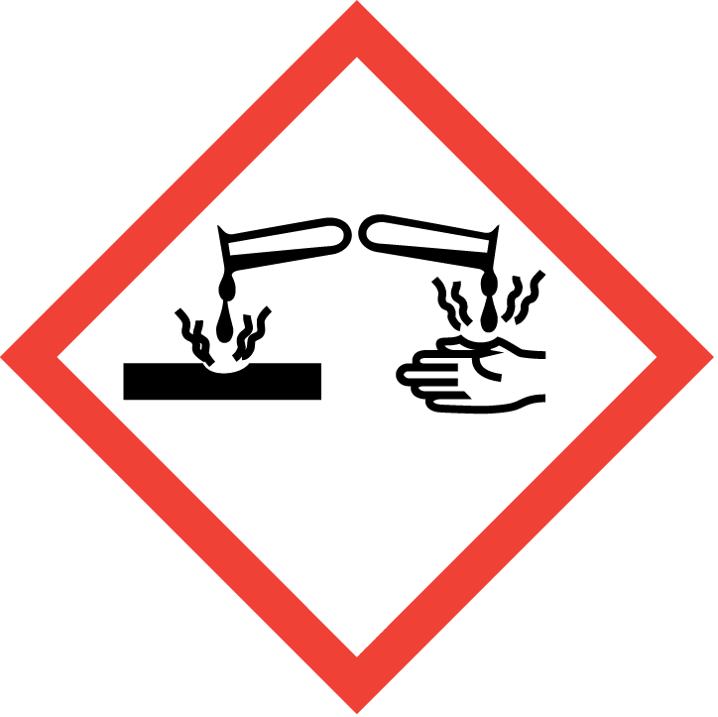
Signal word (GHS CA) | : | Danger

Hazard statements (GHS-CA) | : | H314 - Causes severe skin burns and eye damage.  Causes severe damage to the respiratory tract
Precautionary statements (GHS-CA) | : | P101 - If medical advice is needed, have product container or label at hand.  P102 - Keep out of reach of children.  P103 - Read label before use.  P260 - Do not breathe dust/fume/gas/mist/vapours/spray.  P264 - Wash hands, forearms and face thoroughly after handling.  P280 - Wear protective gloves/protective clothing/eye protection/face protection.  P301+P330+P331 - IF SWALLOWED: Rinse mouth. Do NOT induce vomiting  P303+P361+P353 - IF ON SKIN (or hair): Take off immediately all contaminated clothing. Rinse skin with water .  P363 - Wash contaminated clothing before reuse.  P304+P340 - IF INHALED: Remove person to fresh air and keep comfortable for breathing.  P305+P351+P338 - IF IN EYES: Rinse cautiously with water for several minutes. Remove contact lenses, if present and easy to do. Continue rinsing.  P310 - Immediately call a POISON CENTER or doctor.  P405 - Store locked up.  P501 - Dispose of contents/container to hazardous or special waste collection point, in accordance with local, regional, national and/or international regulation.

2.3. Other hazards
No additional information available

2.4. Unknown acute toxicity (GHS CA)
Not applicable

SECTION 3: Composition/information on ingredients

3.1. Substances
Not applicable

3.2. Mixtures
Name | Chemical name / Synonyms | Product identifier | %
2-Amino-2-methyl-1-propanol | 2-Amino-2-methylpropan-1-ol / Isobutanol-2-amine / Isobutanolamine / Propan-1-ol, 2-amino-2-methyl- / 1-Propanol, 2-amino-2-methyl- / 2-Amino-2-methylpropanol / AMINOMETHYL PROPANOL / Aminomethyl propanol / AMP / Aminomethylpropanol | CAS-No.: 124-68-5 | 10 – 30

Comments | : | *Chemical name, CAS number and/or exact concentration have been withheld as a trade secret

SECTION 4: First-aid measures

4.1. Description of first aid measures
First-aid measures after inhalation | : | If breathing is difficult, remove victim to fresh air and keep at rest in a position comfortable for breathing. Immediately call a POISON CENTER/doctor.
First-aid measures after skin contact | : | If on skin (or hair): Take off immediately all contaminated clothing. Rinse skin with water/shower. Immediately call a POISON CENTER or doctor.
First-aid measures after eye contact | : | IF IN EYES: Rinse cautiously with water for several minutes. Remove contact lenses, if present and easy to do. Continue rinsing. Immediately call a POISON CENTER/doctor.
First-aid measures after ingestion | : | IF SWALLOWED: rinse mouth. Do NOT induce vomiting. Immediately call a POISON CENTER or doctor. Never give anything by mouth to an unconscious person.

4.2. Most important symptoms and effects (acute and delayed)
Symptoms/effects after inhalation | : | Causes burns to the respiratory system.
Symptoms/effects after skin contact | : | Causes severe skin burns. Symptoms may include redness, pain, blisters.
Symptoms/effects after eye contact | : | Causes serious eye damage. Symptoms may include discomfort or pain, excess blinking and tear production, with marked redness and swelling of the conjunctiva. May cause burns.
Symptoms/effects after ingestion | : | May be harmful if swallowed. May cause gastrointestinal irritation, nausea, vomiting and diarrhea. May cause burns or irritation of the linings of the mouth, throat, and gastrointestinal tract.

4.3. Immediate medical attention and special treatment, if necessary
Other medical advice or treatment | : | Symptoms may be delayed. In case of accident or if you feel unwell, seek medical advice immediately (show the label where possible).

SECTION 5: Fire-fighting measures

5.1. Suitable extinguishing media
Suitable extinguishing media | : | Use extinguishing media appropriate for surrounding fire.

5.2. Unsuitable extinguishing media
Unsuitable extinguishing media | : | Do not use water jet.

5.3. Specific hazards arising from the hazardous product
Fire hazard | : | Products of combustion may include, and are not limited to: oxides of carbon.

5.4. Special protective equipment and precautions for fire-fighters
Protection during firefighting | : | Keep upwind of fire. Wear full fire fighting turn-out gear (full Bunker gear) and respiratory protection (SCBA).

SECTION 6: Accidental release measures

6.1. Personal precautions, protective equipment and emergency procedures
General measures | : | Avoid contact with skin and eyes. Use personal protection recommended in Section 8. Isolate the hazard area and deny entry to unnecessary and unprotected personnel.

6.2. Methods and materials for containment and cleaning up
For containment | : | Stop leak if safe to do so. Absorb and/or contain spill with inert material (sand, vermiculite or other appropriate material), then place in suitable container. Do not flush into surface water or sewer system. Wear recommended personal protective equipment.
Methods for cleaning up | : | Sweep or shovel spills into appropriate container for disposal. Provide ventilation.

6.3. Reference to other sections
For further information refer to section 8: "Exposure controls/personal protection"

SECTION 7: Handling and storage

7.1. Precautions for safe handling
Precautions for safe handling | : | Do not get in eyes, on skin, or on clothing. Do not breathe dust/fume/gas/mist/vapours/spray. Do not swallow. Handle and open container with care. When using do not eat, drink or smoke. Use only in well-ventilated areas. Wear appropriate PPE (see Section 8).
Hygiene measures | : | Take off immediately all contaminated clothing and wash it before reuse. Wash hands, forearms and face thoroughly after handling.

7.2. Conditions for safe storage, including any incompatibilities
Storage conditions | : | Keep out of the reach of children. Keep container tightly closed. Store locked up.

SECTION 8: Exposure controls/personal protection

8.1. Control parameters
No additional information available

8.2. Appropriate engineering controls
Appropriate engineering controls | : | Ensure good ventilation of the work station. Provide readily accessible eye wash stations and safety showers.
Environmental exposure controls | : | Avoid release to the environment.

8.3. Individual protection measures/Personal protective equipment
Hand protection:
Wear suitable gloves resistant to chemical penetration. Consult glove manufacturer's product information on material suitability and material thickness.

Eye protection:
Wear eye/face protection

Skin and body protection:
Wear suitable protective clothing

Respiratory protection:
In case of insufficient ventilation, wear suitable respiratory equipment. Respirator selection must be based on known or anticipated exposure levels, the hazards of the product and the safe working limits of the selected respirator. SDSs cannot provide detailed and complete respiratory protection guidelines. Selection of respiratory protection must be done by a qualified person who has assessed the work environment.

Other information:
Handle in accordance with good industrial hygiene and safety procedures. Do not eat, drink or smoke when using this product.

SECTION 9: Physical and chemical properties

9.1. Information on basic physical and chemical properties
Physical state | : | Liquid
Appearance | : | Clear.
Colour | : | Clear
Odour | : | Amine
Odour threshold | : | No data available
pH | : | 12.6
Relative evaporation rate (butylacetate=1) | : | No data available
Relative evaporation rate (ether=1) | : | No data available
Melting point | : | No data available
Freezing point | : | No data available
Boiling point | : | 100 °C (212 °F)
Flash point | : | Not applicable
Auto-ignition temperature | : | No data available
Decomposition temperature | : | No data available
Flammability (solid, gas) | : | Not flammable
Vapour pressure | : | No data available
Relative vapour density at 20°C | : | No data available
Relative density | : | 0.98
Solubility | : | Miscible.
Partition coefficient n-octanol/water | : | No data available
Viscosity, kinematic | : | 10 mm²/s
Explosive limits | : | No data available

9.2. Other information
No additional information available

SECTION 10: Stability and reactivity
Reactivity | : | No dangerous reactions known under normal conditions of use.
Chemical stability | : | Stable under normal conditions.
Possibility of hazardous reactions | : | No dangerous reactions known under normal conditions of use.
Conditions to avoid | : | Heat. Incompatible materials.
Incompatible materials | : | Acids.
Hazardous decomposition products | : | May include, and are not limited to: oxides of carbon.
Hardening time: | : | No additional information available

SECTION 11: Toxicological information

11.1. Information on toxicological effects
Acute toxicity (oral) | : | Not classified.
Acute toxicity (dermal) | : | Not classified.
Acute toxicity (inhalation) | : | Not classified.

2-Amino-2-methyl-1-propanol (124-68-5)
LD50 oral rat | 2900 mg/kg
LD50 dermal rabbit | > 2000 mg/kg
ATE CA (oral) | 2900 mg/kg bodyweight

Skin corrosion/irritation | : | Causes severe skin burns.  pH: 12.6

Serious eye damage/irritation | : | Causes serious eye damage.  pH: 12.6

Respiratory or skin sensitization | : | Not classified.

Germ cell mutagenicity | : | Not classified.

Carcinogenicity | : | Not classified.

Reproductive toxicity | : | Not classified.

STOT-single exposure | : | Not classified.

STOT-repeated exposure | : | Not classified.

Aspiration hazard | : | Not classified.

Symptoms/effects after inhalation | : | Causes burns to the respiratory system.
Symptoms/effects after skin contact | : | Causes severe skin burns. Symptoms may include redness, pain, blisters.
Symptoms/effects after eye contact | : | Causes serious eye damage. Symptoms may include discomfort or pain, excess blinking and tear production, with marked redness and swelling of the conjunctiva. May cause burns.
Symptoms/effects after ingestion | : | May be harmful if swallowed. May cause gastrointestinal irritation, nausea, vomiting and diarrhea. May cause burns or irritation of the linings of the mouth, throat, and gastrointestinal tract.
Other information | : | Likely routes of exposure: ingestion, inhalation, skin and eye.

SECTION 12: Ecological information

12.1. Toxicity
Ecology - general | : | Harmful to aquatic life with long lasting effects.

12.2. Persistence and degradability
No additional information available

12.3. Bioaccumulative potential
No additional information available

12.4. Mobility in soil
No additional information available

12.5. Other adverse effects
No additional information available

SECTION 13: Disposal considerations

13.1. Disposal methods
Product/Packaging disposal recommendations | : | Dispose of contents/container to hazardous or special waste collection point, in accordance with local, regional, national and/or international regulation. The generation of waste should be avoided or minimized wherever possible.

SECTION 14: Transport information
In accordance with TDG

14.1. UN number
UN-No. (TDG) | : | UN3267

14.2. UN proper shipping name
Proper Shipping Name (TDG) | : | CORROSIVE LIQUID, BASIC, ORGANIC, N.O.S. (2-Amino-2-methyl-1-propanol)

14.3. Transport hazard class(es)
TDG
Transport hazard class(es) (TDG) | : | 8
Hazard labels (TDG) | : | 8
 | : | 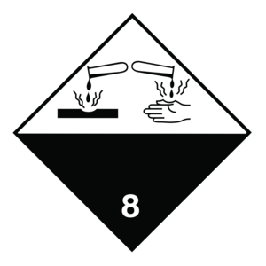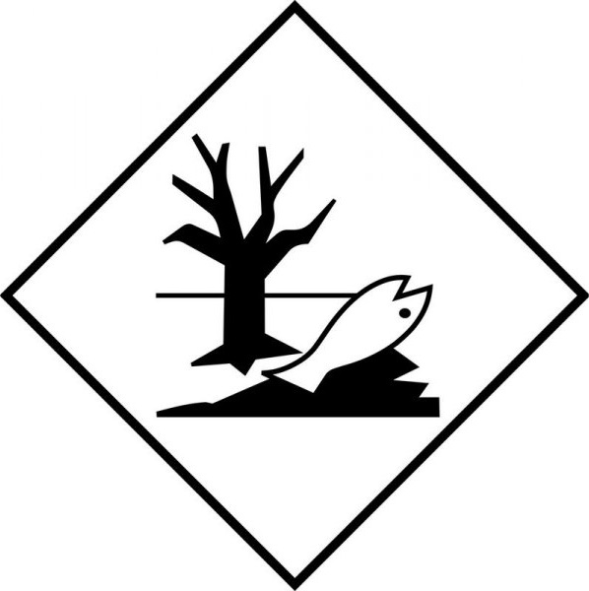

14.4. Packing group
Packing group (TDG) | : | I

14.5. Environmental hazards
Dangerous for the environment | : | Yes
Marine pollutant | : | Yes

14.6. Special precautions for user
Special transport precautions | : | Do not handle until all safety precautions have been read and understood.

TDG
UN-No. (TDG) | : | UN3267
TDG Special Provisions | : | 16 - (1) The technical name of at least one of the most dangerous substances that predominantly contributes to the hazard or hazards posed by the dangerous goods must be shown, in parentheses, on the shipping document following the shipping name in accordance with clause 3.5(1)(c)(ii)(A) of Part 3 (Documentation). The technical name must also be shown, in parentheses, on a small means of containment or on a tag following the shipping name in accordance with subsections 4.11(2) and (3) of Part 4 (Dangerous Goods Safety Marks).  (2) Despite subsection (1), the technical name for the following dangerous goods is not required to be shown on a shipping document or on a small means of containment when Canadian law for domestic transport or an international convention for international transport prohibits the disclosure of the technical name:  (a) UN1544, ALKALOID SALTS, SOLID, N.O.S. or ALKALOIDS, SOLID, N.O.S;  (b) UN1851, MEDICINE, LIQUID, TOXIC, N.O.S;  (c) UN3140, ALKALOID SALTS, LIQUID, N.O.S. or ALKALOIDS, LIQUID, N.O.S;  (d) UN3248, MEDICINE, LIQUID, FLAMMABLE, TOXIC, N.O.S; or  (e) UN3249, MEDICINE, SOLID, TOXIC, N.O.S.  (3) Despite subsection (1), the technical name for the following dangerous goods is not required to be shown on a small means of containment:  (a) UN2814, INFECTIOUS SUBSTANCE, AFFECTING HUMANS; or  (b) UN2900, INFECTIOUS SUBSTANCE, AFFECTING ANIMALS.
ERAP Index | : | 3000
Explosive Limit and Limited Quantity Index | : | 0
Excepted quantities (TDG) | : | E0
Passenger Carrying Road Vehicle or Passenger Carrying Railway Vehicle Index | : | 0.5 L
Emergency Response Guide (ERG) Number | : | 153

14.7. Transport in bulk according to Annex II of MARPOL 73/78 and the IBC Code
Not applicable

SECTION 15: Regulatory information

15.1. National regulations
No additional information available

15.2. International regulations
No additional information available

SECTION 16: Other information
Issue date | : | 10-17-2017
Revision date | : | 05-24-2023
Supersedes | : | 01-22-2018

NFPA health hazard | : | 3 - Materials that, under emergency conditions, can cause serious or permanent injury. | 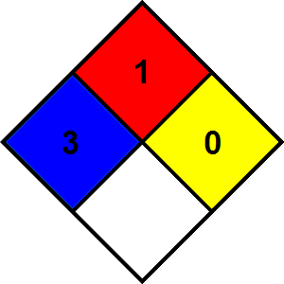
NFPA fire hazard | : | 1 - Materials that must be preheated before ignition can occur.
NFPA reactivity | : | 0 - Material that in themselves are normally stable, even under fire conditions.

Hazard Rating
Health | : | 3 Serious Hazard - Major injury likely unless prompt action is taken and medical treatment is given
Flammability | : | 1 Slight Hazard - Materials that must be preheated before ignition will occur. Includes liquids, solids and semi solids having a flash point above 200 F. (Class IIIB)
Physical | : | 0 Minimal Hazard - Materials that are normally stable, even under fire conditions, and will NOT react with water, polymerize, decompose, condense, or self-react. Non-Explosives.
Personal protection | : | B - Safety glasses, Gloves

Indication of changes
Section | Changed item | Change | Comments
2 | Classification (GHS CA) | Added | V2.1
SDS | SDS update | Modified | V2.1

Other information | : | None.
Prepared by | : |   Nexreg Compliance Inc.  www.Nexreg.com

Safety Data Sheet (SDS), Canada - Nexreg 2022
Disclaimer: We believe the statements, technical information and recommendations contained herein are reliable, but they are given without warranty or guarantee of any kind. The information contained in this document applies to this specific material as supplied. It may not be valid for this material if it is used in combination with any other materials. It is the user’s responsibility to satisfy oneself as to the suitability and completeness of this information for the user’s own particular use.

