SECTION 1: Identification

1.1. Identification
Product form | : | Mixture
Product name | : | eXact color Thickener

1.2. Recommended use and restrictions on use
Recommended use | : | Caulking
This SDS is designed for workplace employees, emergency personnel and for other situations where there is potential for large-scale or prolonged exposure, in accordance with the OSHA requirements.
This SDS is not applicable for consumer use of our products. For consumer use, all precautionary and first aid language is provided on the product label, SDS or both in accordance with applicable government regulations

1.3. Supplier
Sashco Inc.
14802 Grant St.
Thornton, CO, 80023
USA
T 800-767-5656
info@sashco.com

1.4. Emergency telephone number
Emergency number | : | 800-535-5053

SECTION 2: Hazard(s) identification

2.1. Classification of the substance or mixture

GHS US classification
Skin Corr. 1 | Causes severe skin burns
Eye Dam. 1 | Causes serious eye damage
HHNOC 1 | Causes severe damage to the respiratory tract

2.2. GHS Label elements, including precautionary statements

GHS US labeling
Hazard pictograms (GHS US) | : | 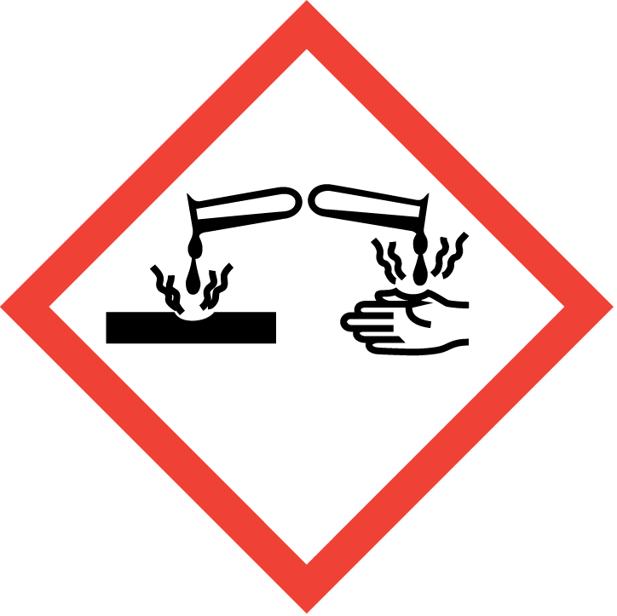
Signal word (GHS US) | : | Danger
Hazard statements (GHS US) | : | Causes severe skin burns and eye damage  Causes severe damage to the respiratory tract
Precautionary statements (GHS US) | : | If medical advice is needed, have product container or label at hand.  Keep out of reach of children.  Read label before use.  Do not breathe dust/fume/gas/mist/vapors/spray.  Wash hands, forearms and face thoroughly after handling.  Wear protective gloves/protective clothing/eye protection/face protection.  If swallowed: rinse mouth. Do NOT induce vomiting.  If on skin (or hair): Take off immediately all contaminated clothing. Rinse skin with water/shower.  Wash contaminated clothing before reuse.  If inhaled: Remove person to fresh air and keep comfortable for breathing.  IF IN EYES: Rinse cautiously with water for several minutes. Remove contact lenses, if present and easy to do. Continue rinsing.  Immediately call a poison center or doctor.  Store locked up.  Dispose of contents/container to hazardous or special waste collection point, in accordance with local, regional, national and/or international regulation.

2.3. Other hazards which do not result in classification
No additional information available

2.4. Unknown acute toxicity (GHS US)
Not applicable

SECTION 3: Composition/Information on ingredients

3.1. Substances
Not applicable

3.2. Mixtures
Name | Product identifier | %
2-Amino-2-methyl-1-propanol | CAS-No.: 124-68-5 | 10 – 30
*Chemical name, CAS number and/or exact concentration have been withheld as a trade secret

SECTION 4: First-aid measures

4.1. Description of first aid measures
First-aid measures after inhalation | : | If breathing is difficult, remove victim to fresh air and keep at rest in a position comfortable for breathing. Immediately call a poison center or doctor/physician.
First-aid measures after skin contact | : | If on skin (or hair): Take off immediately all contaminated clothing. Rinse skin with water/shower. Immediately call a POISON CENTER or doctor.
First-aid measures after eye contact | : | IF IN EYES: Rinse cautiously with water for several minutes. Remove contact lenses, if present and easy to do. Continue rinsing. Immediately call a poison center or doctor/physician.
First-aid measures after ingestion | : | IF SWALLOWED: Rinse mouth. Do NOT induce vomiting. Immediately call a POISON CENTER or doctor. Never give anything by mouth to an unconscious person.

4.2. Most important symptoms and effects (acute and delayed)
Symptoms/effects after inhalation | : | Causes burns to the respiratory system.
Symptoms/effects after skin contact | : | Causes severe skin burns. Symptoms may include redness, pain, blisters.
Symptoms/effects after eye contact | : | Causes serious eye damage. Symptoms may include discomfort or pain, excess blinking and tear production, with marked redness and swelling of the conjunctiva. May cause burns.
Symptoms/effects after ingestion | : | May be harmful if swallowed. May cause gastrointestinal irritation, nausea, vomiting and diarrhea. May cause burns or irritation of the linings of the mouth, throat, and gastrointestinal tract.

4.3. Immediate medical attention and special treatment, if necessary
Symptoms may be delayed. In case of accident or if you feel unwell, seek medical advice immediately (show the label where possible).

SECTION 5: Fire-fighting measures

5.1. Suitable (and unsuitable) extinguishing media
Suitable extinguishing media | : | Use extinguishing media appropriate for surrounding fire.
Unsuitable extinguishing media | : | Do not use water jet.

5.2. Specific hazards arising from the chemical
Fire hazard | : | Products of combustion may include, and are not limited to: oxides of carbon.

5.3. Special protective equipment and precautions for fire-fighters
Protection during firefighting | : | Keep upwind of fire. Wear full fire fighting turn-out gear (full Bunker gear) and respiratory protection (SCBA).

SECTION 6: Accidental release measures

6.1. Personal precautions, protective equipment and emergency procedures
General measures | : | Avoid contact with skin and eyes. Use personal protection recommended in Section 8. Isolate the hazard area and deny entry to unnecessary and unprotected personnel.

6.1.1. For non-emergency personnel
Emergency procedures | : | Do not touch or walk on the spilled product.

6.1.2. For emergency responders
No additional information available

6.2. Environmental precautions
Prevent entry to sewers and public waters. Notify authorities if product enters sewers or public waters.

6.3. Methods and material for containment and cleaning up
For containment | : | Stop leak if safe to do so. Absorb and/or contain spill with inert material (sand, vermiculite or other appropriate material), then place in suitable container. Do not flush into surface water or sewer system. Wear recommended personal protective equipment.
Methods for cleaning up | : | Sweep or shovel spills into appropriate container for disposal. Provide ventilation.

6.4. Reference to other sections
For further information refer to section 8: "Exposure controls/personal protection".

SECTION 7: Handling and storage

7.1. Precautions for safe handling
Precautions for safe handling | : | Do not get in eyes, on skin, or on clothing. Do not breathe dust/fume/gas/mist/vapors/spray. Do not swallow. Handle and open container with care. When using do not eat, drink or smoke. Use only in well-ventilated areas. Wear appropriate PPE (see Section 8).
Hygiene measures | : | Take off immediately all contaminated clothing and wash it before reuse. Wash hands, forearms and face thoroughly after handling.

7.2. Conditions for safe storage, including any incompatibilities
Storage conditions | : | Keep out of the reach of children. Keep container tightly closed. Store locked up.

SECTION 8: Exposure controls/personal protection

8.1. Control parameters

eXact color Thickener
No additional information available

2-Amino-2-methyl-1-propanol (124-68-5)
No additional information available

8.2. Appropriate engineering controls
Appropriate engineering controls | : | Ensure good ventilation of the work station. Provide readily accessible eye wash stations and safety showers.
Environmental exposure controls | : | Avoid release to the environment.

8.3. Individual protection measures/Personal protective equipment
Hand protection:
Wear suitable gloves resistant to chemical penetration. Consult glove manufacturer's product information on material suitability and material thickness.

Eye protection:
Wear eye/face protection

Skin and body protection:
Wear suitable protective clothing

Respiratory protection:
In case of insufficient ventilation, wear suitable respiratory equipment. Respirator selection must be based on known or anticipated exposure levels, the hazards of the product and the safe working limits of the selected respirator. SDSs cannot provide detailed and complete respiratory protection guidelines. Selection of respiratory protection must be done by a qualified person who has assessed the work environment.

Other information:
Handle in accordance with good industrial hygiene and safety procedures. Do not eat, drink or smoke when using this product.

SECTION 9: Physical and chemical properties

9.1. Information on basic physical and chemical properties
Physical state | : | Liquid
Appearance | : | Clear.
Color | : | Clear
Odor | : | Amine
Odor threshold | : | No data available
pH | : | 12.6
Melting point | : | No data available
Freezing point | : | No data available
Boiling point | : | 100 °C (212 °F)
Flash point | : | Not applicable
Relative evaporation rate (butyl acetate=1) | : | No data available
Flammability (solid, gas) | : | Not flammable
Vapor pressure | : | No data available
Relative vapor density at 20°C | : | No data available
Relative density | : | 0.98
Solubility | : | Miscible.
Partition coefficient n-octanol/water | : | No data available
Auto-ignition temperature | : | No data available
Decomposition temperature | : | No data available
Viscosity, kinematic | : | 10 mm²/s
Viscosity, dynamic | : | No data available
Explosion limits | : | No data available
Explosive properties | : | No data available
Oxidizing properties | : | No data available

9.2. Other information
No additional information available

SECTION 10: Stability and reactivity

10.1. Reactivity
No dangerous reactions known under normal conditions of use.

10.2. Chemical stability
Stable under normal conditions.

10.3. Possibility of hazardous reactions
No dangerous reactions known under normal conditions of use.

10.4. Conditions to avoid
Heat. Incompatible materials.

10.5. Incompatible materials
Acids.

10.6. Hazardous decomposition products
May include, and are not limited to: oxides of carbon.

SECTION 11: Toxicological information

11.1. Information on toxicological effects
Acute toxicity (oral) | : | Not classified
Acute toxicity (dermal) | : | Not classified
Acute toxicity (inhalation) | : | Not classified

2-Amino-2-methyl-1-propanol (124-68-5)
LD50 oral rat | 2900 mg/kg
LD50 dermal rabbit | > 2000 mg/kg
ATE US (oral) | 2900 mg/kg body weight

Skin corrosion/irritation | : | Causes severe skin burns.  pH: 12.6

Serious eye damage/irritation | : | Causes serious eye damage.  pH: 12.6

Respiratory or skin sensitization | : | Not classified

Germ cell mutagenicity | : | Not classified

Carcinogenicity | : | Not classified

Reproductive toxicity | : | Not classified

STOT-single exposure | : | Not classified

STOT-repeated exposure | : | Not classified

Aspiration hazard | : | Not classified
Viscosity, kinematic | : | 10 mm²/s

Symptoms/effects after inhalation | : | Causes burns to the respiratory system.
Symptoms/effects after skin contact | : | Causes severe skin burns. Symptoms may include redness, pain, blisters.
Symptoms/effects after eye contact | : | Causes serious eye damage. Symptoms may include discomfort or pain, excess blinking and tear production, with marked redness and swelling of the conjunctiva. May cause burns.
Symptoms/effects after ingestion | : | May be harmful if swallowed. May cause gastrointestinal irritation, nausea, vomiting and diarrhea. May cause burns or irritation of the linings of the mouth, throat, and gastrointestinal tract.
Other information | : | Likely routes of exposure: ingestion, inhalation, skin and eye.

SECTION 12: Ecological information

12.1. Toxicity
Ecology - general | : | Harmful to aquatic life with long lasting effects.

12.2. Persistence and degradability
No additional information available

12.3. Bioaccumulative potential
No additional information available

12.4. Mobility in soil
No additional information available

12.5. Other adverse effects
No additional information available

SECTION 13: Disposal considerations

13.1. Disposal methods
Product/Packaging disposal recommendations | : | Dispose of contents/container to hazardous or special waste collection point, in accordance with local, regional, national and/or international regulation. The generation of waste should be avoided or minimized wherever possible.

SECTION 14: Transport information
In accordance with DOT / IMDG / IATA

14.1. UN number
DOT NA No | : | UN3267
UN-No. (IMDG) | : | 3267
UN-No. (IATA) | : | 3267

14.2. UN proper shipping name
Proper Shipping Name (DOT) | : | Corrosive liquid, basic, organic, n.o.s. (2-Amino-2-methyl-1-propanol)
Proper Shipping Name (IMDG) | : | CORROSIVE LIQUID, BASIC, ORGANIC, N.O.S. (2-Amino-2-methyl-1-propanol)
Proper Shipping Name (IATA) | : | Corrosive liquid, basic, organic, n.o.s. (2-Amino-2-methyl-1-propanol)

14.3. Transport hazard class(es)
DOT
Transport hazard class(es) (DOT) | : | 8
Hazard labels (DOT) | : | 8
 |  | 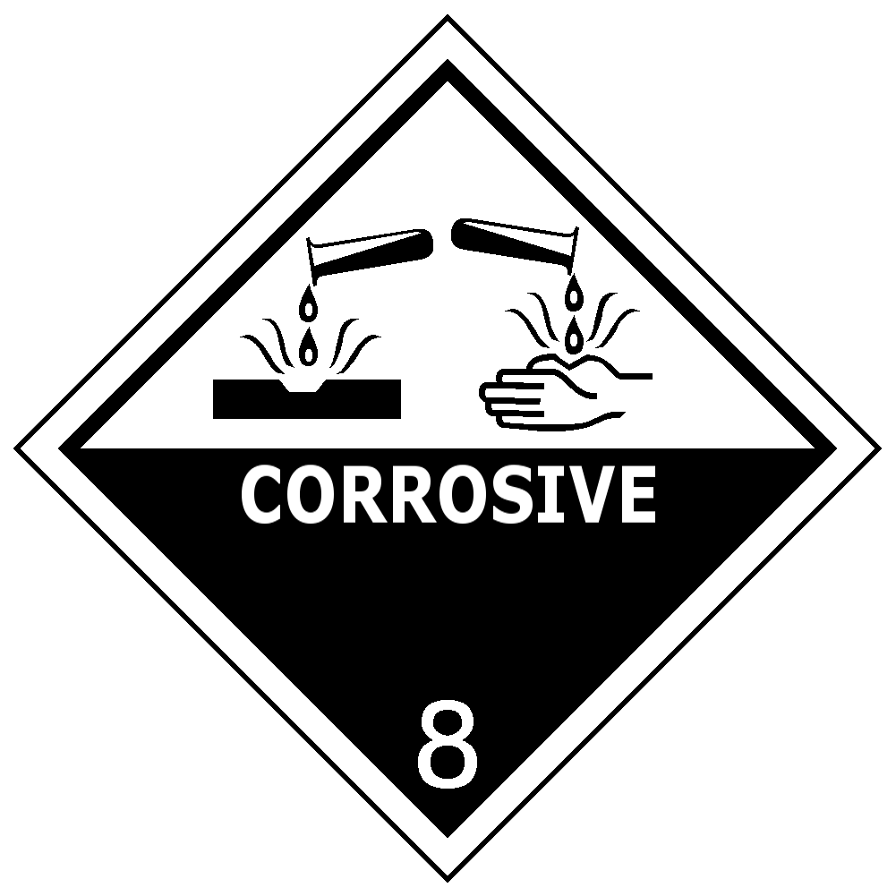

IMDG
Transport hazard class(es) (IMDG) | : | 8
Hazard labels (IMDG) | : | 8
 |  | 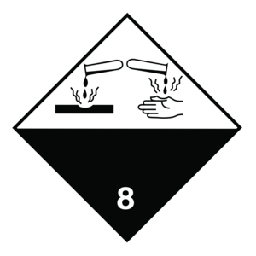

IATA
Transport hazard class(es) (IATA) | : | 8
Hazard labels (IATA) | : | 8

14.4. Packing group
Packing group (DOT) | : | III
Packing group (IMDG) | : | III
Packing group (IATA) | : | III

14.5. Environmental hazards
Other information | : | No supplementary information available.

14.6. Special precautions for user
Special transport precautions | : | Do not handle until all safety precautions have been read and understood.

14.7. Transport in bulk according to Annex II of MARPOL 73/78 and the IBC Code
Not applicable

SECTION 15: Regulatory information

15.1. US Federal regulations
No additional information available

15.2. International regulations
No additional information available

15.3. US State regulations

California Proposition 65 - This product does not contain any substances known to the state of California to cause cancer, developmental and/or reproductive harm

SECTION 16: Other information
according to the Hazard Communication Standard (CFR29 1910.1200) HazCom 2012.
Issue date | : | 1/22/2016
Revision date | : | 5/02/2024
Other information | : | None.
Prepared by | : | Nexreg Compliance Inc.  www.Nexreg.com

Full text of H-phrases
Eye Dam. 1 | Serious eye damage/eye irritation Category 1
HHNOC 1 | Health hazard not otherwise classified, category 1
Skin Corr. 1 | Skin corrosion/irritation Category 1

NFPA health hazard | : | 3 - Materials that, under emergency conditions, can cause serious or permanent injury. | 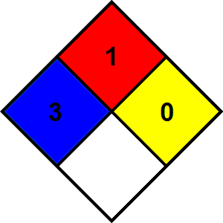
NFPA fire hazard | : | 1 - Materials that must be preheated before ignition can occur.
NFPA reactivity | : | 0 - Material that in themselves are normally stable, even under fire conditions.

Hazard Rating
Health | : | 3 Serious Hazard - Major injury likely unless prompt action is taken and medical treatment is given
Flammability | : | 1 Slight Hazard - Materials that must be preheated before ignition will occur. Includes liquids, solids and semi solids having a flash point above 200 F. (Class IIIB)
Physical | : | 0 Minimal Hazard - Materials that are normally stable, even under fire conditions, and will NOT react with water, polymerize, decompose, condense, or self-react. Non-Explosives.
Personal protection | : | B - Safety glasses, Gloves

Indication of changes:
Section | Changed item | Change | Comments
2 | GHS-US classification | Modified | V4.1
SDS | SDS update | Modified | V4.1
14 | Packing group | Modified | V4.2
14 | IMDG - All information  IATA – All information | Added | V4.3
Safety Data Sheet (SDS), USA
Disclaimer: We believe the statements, technical information and recommendations contained herein are reliable, but they are given without warranty or guarantee of any kind. The information contained in this document applies to this specific material as supplied. It may not be valid for this material if it is used in combination with any other materials. It is the user’s responsibility to satisfy oneself as to the suitability and completeness of this information for the user’s own particular use.

